Auto Pac food and cosmetic item processing machineries
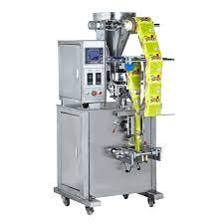  200-5001000gm auto powder-granular packing machine | 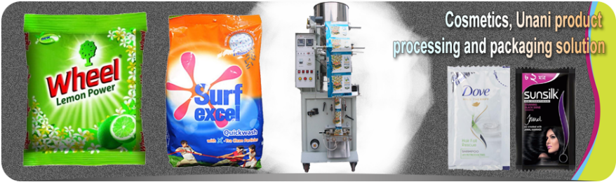  Washing powder-Cosmetic item processing and packing machineries  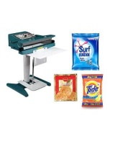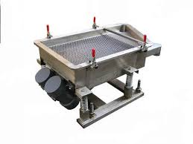  Manual packing sealing machine seed-granular shifter machine
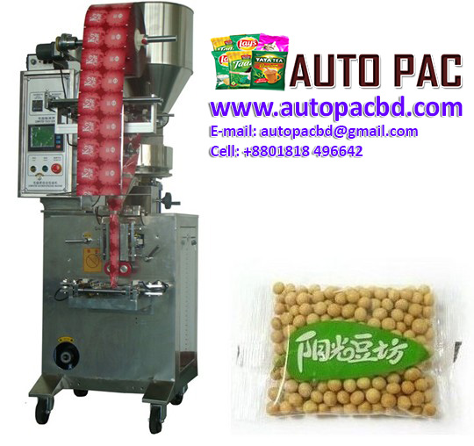  10-200gm auto powder-seed packing machine | 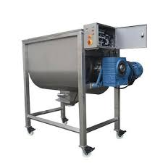  Mass mixer machine/ Ribbon type
Digital auto all liquid item filling machine | 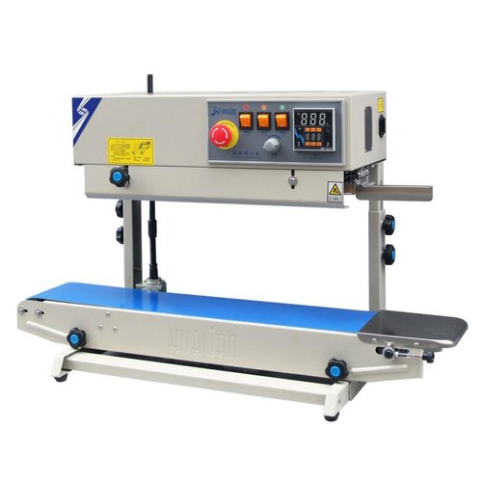  Load unload product trolly Semi auto packing machine
Auto Pac machineries
4-nozzle Semi auto Oil filling line | 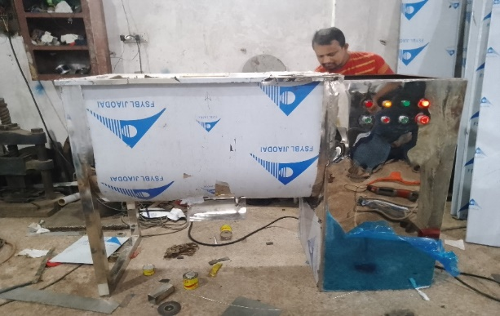  Auto ribbon mixer machine
4-nozzle all liquid filling machine | 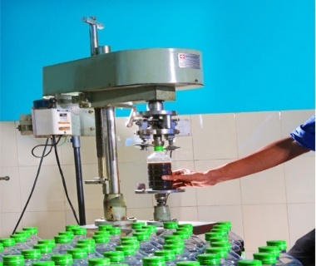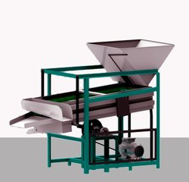  Semi auto bottle capping machine- auto shifter machine
Single and jacket type all liquid ietm SS mixer holding tank | 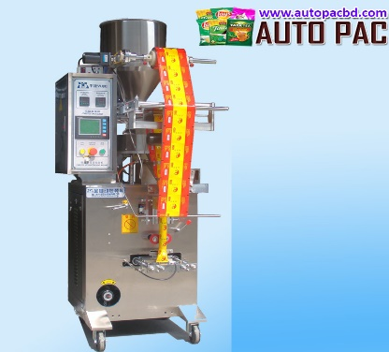  Powder-seed-granular auto center seal packing machine
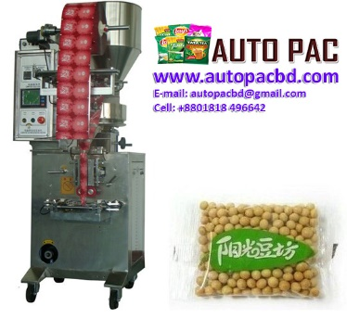  Powder-seed auto packing machine | Semi auto bottle capping machine
Auto Pac machineries 01631769707-01818496642- email: autopacbd@gmail.com web: autopacbd.com

